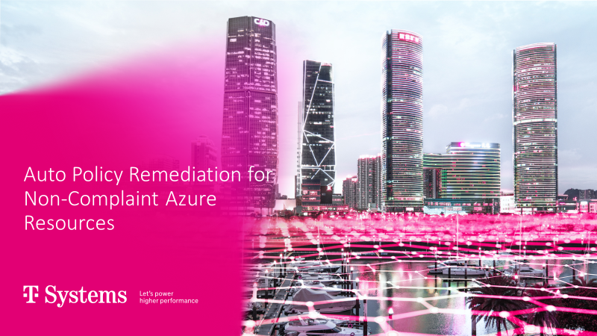

POC ACTIVITY DOCUMENT
FOR
Auto Policy Remediation

Table of Contents

- Objective
- Challenges
- Solution
- Assumptions/Pre-requisites
- Architectural Diagram
- Configuration and set-up
- Results
- References

1.0 objective:

The primary goal of this document is to guide readers through the step-by-step procedure for establishing an event-driven alert system that ensures Azure Policy compliance. It further outlines the automation of policy remediation for Azure resources that do not adhere to compliance standards. The document aims to provide a clear and comprehensive understanding of setting up this essential aspect of Azure governance and management.

2.0 Challenges:

Policy compliance alerting and auto policy remediation for non-compliant resources pose several challenges in the realm of cloud governance. One major challenge is the complexity of managing a large and dynamic cloud environment, where resources are constantly changing. Ensuring that all resources adhere to company policies and promptly addressing non-compliance is a daunting task. Additionally, setting up an effective alerting system and automation for remediation requires careful planning and continuous monitoring. There is also the challenge of balancing compliance with business agility, as stringent policies can sometimes hinder rapid resource deployment. Therefore, organizations must strike a delicate balance between enforcing policies and maintaining operational flexibility, which is not always a straightforward task.

3.0 Solution:

In our comprehensive solution, the initial imperative is to pinpoint the precise data source required for capturing and monitoring Azure Policy regulatory compliance details. The preferred and invaluable data source for this purpose is the PolicyInsights event data. This rich source of information encompasses three distinct event types within the Azure environment: Policy Compliance Status Added, Policy Compliance Status Changed, and Policy Compliance Status Deleted. The next logical query is: How can one efficiently access and harness this PolicyInsights Event data to initiate proactive alerts, ensuring timely notifications when critical policy events transpire, such as compliance alterations? This intricate challenge is adeptly addressed by the architectural framework we have meticulously designed.
Furthermore, within this framework, an integral component is the policy remediation task, which ensures that not only are compliance issues detected but that they are also automatically addressed. This means that when non-compliant Azure resources are identified through the PolicyInsights data, corresponding remediation actions can be automatically triggered, thus maintaining a proactive and automated approach to policy enforcement and remediation. This holistic solution facilitates a seamless and efficient approach to Azure Policy compliance and empowers organizations to maintain regulatory adherence effortlessly.

4.0 Assumptions/prerequisites:

Following are the resources needed for this POC to be carried out,
- Log Analytics Workspace
- Azure Monitor
- Azure Function app
- Managed Identity for Function app
- Event Grid System Topic
- Event Grid Subscription

5.0 Architectural Diagram:
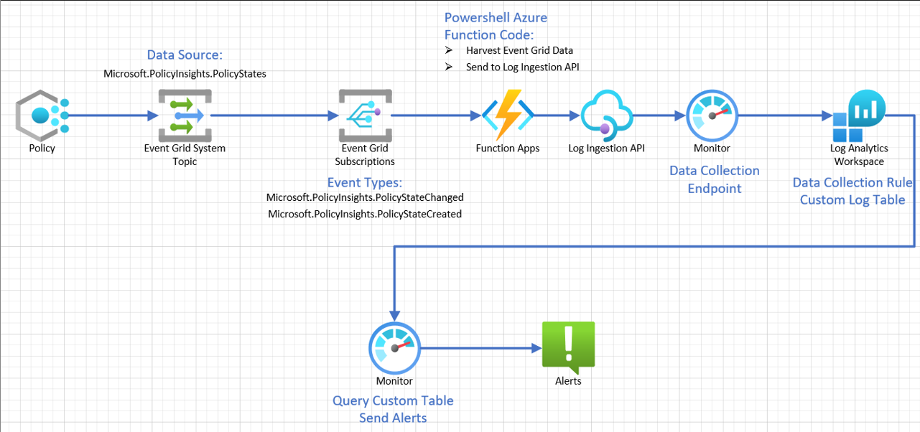

1. Azure Policy: The journey commences with Azure Policy, where we meticulously define and assign policies to manage specific compliance states for Azure resources.

2. Event Grid: As Azure Policy compliance states evolve, Event Grid stands ready to capture these changes by monitoring PolicyInsights events.

3. Event Grid Subscription: To manage this event-driven process seamlessly, we set up an Event Grid Subscription, ensuring that captured events are efficiently routed to an Azure Function. This event-driven mechanism plays a critical role in ensuring timely responses to compliance issues and auto-remediation of non-compliant Azure resources.

4. Azure Function: The Azure Function, empowered with a robust PowerShell script, serves a dual purpose. It not only collects incoming policy event data but also takes on the vital role of automatically remediating non-compliant Azure resources. This script works tirelessly to bring any non-compliant resources back into adherence with the defined policies. Additionally, it leverages the Log Ingestion API to transmit data through the Data Collection Endpoint and Data Collection Rule to the Log Analytics Workspace.

5. Log Ingestion API: The reliable Log Ingestion API takes center stage in facilitating the smooth flow of data through the Data Collection Endpoint and Data Collection Rule to the Log Analytics Workspace.

6. Log Analytics Workspace: Within the Log Analytics Workspace, we create a specialized Custom Table, purpose-built to receive and organize the incoming data routed through the Data Collection Endpoint.

7. Monitor: Azure Monitor plays a pivotal role by actively querying the Custom Table, identifying instances where alerts need to be triggered based on compliance discrepancies.
8. Alert: As the final layer of defense, we meticulously configure an alerting system to activate whenever the Custom Table query uncovers any non-compliance issues, ensuring rapid response and resolution.

6.0 Configuration and set-up:

6.1 Event Grid System Topic:
The Event Grid System Topic will capture the PolicyInsights data so it can be sent to a Log Analytics Workspace.
- Type Event Grid in the Global Azure search and select it.
- Under Azure service events, select System topics.
  - Create New and use these Basic Settings:
  - Change the Topic Types to Microsoft PolicyInsights
  - Ensure that the scope is set to Azure Subscription
  - Ensure that the appropriate Subscription name has been selected.
  - Select the appropriate Resource Group.
  - Give the SystemTopic an appropriate name such as egst-PolicyAlert.
  - Tags as needed.
  - Review and create.
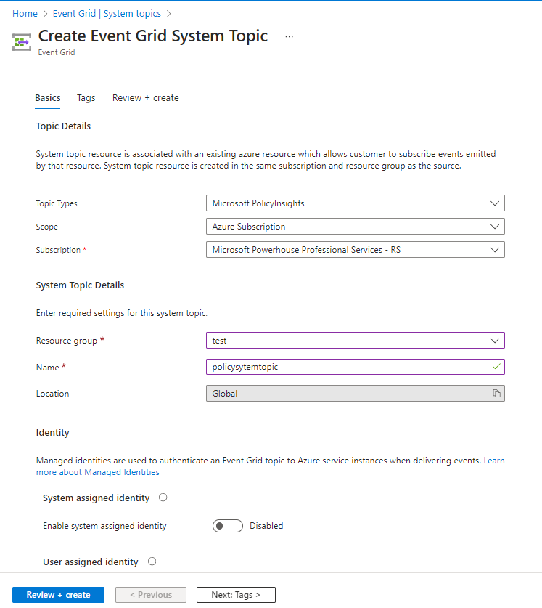

6.2 Function App
The Function App will be used to harvest the PolicyInsights data from the Event Grid and then write it to a Log Analytics Workspace.
- Basics:
  - Go to Azure Global Search and type/select Function App
  - Click Create
  - Select Resource Group where Event Grid resides.
  - Give name to function app according to naming convention and that makes sense for example, Policyapp123or FA-PolicyAlert
  - Publish: Code
  - Runtime Stack: PowerShell Core
  - Version: 7.2 (newest available)
  - Region: Select the region where you are working and have the Event Grid resource located
  - Operating System: Windows
  - Plan type: Consumption (Serverless)
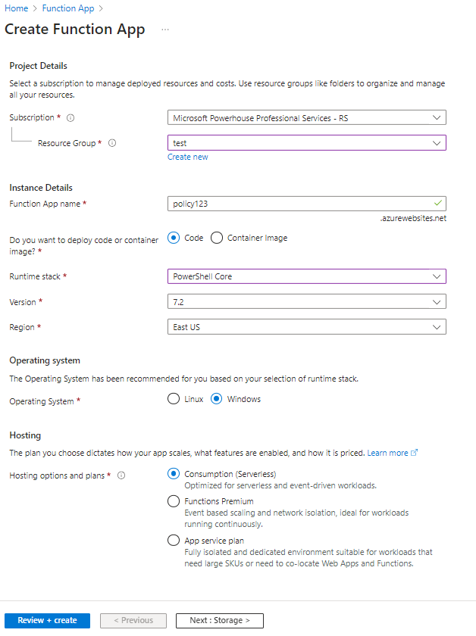
- Hosting: Select a storage account that you already have or accept the storage account that is created automatically.
- Networking: Leave network injection to off
- Monitoring: Enable Applications Insights; accept the newly created application insight.
- Deployment: Accept the defaults.
- Tags: As needed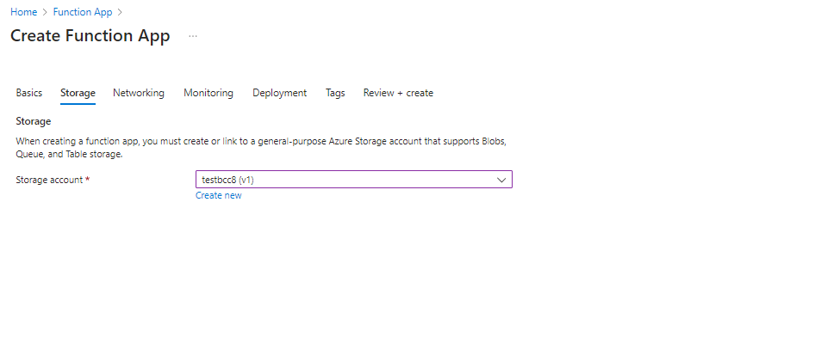
- Review and Create
- Identity: Once the Function App is created, you need to configure the Managed Identity.
  - After updating the slider to enable system assigned managed identity, the following pop up will occur. Click Yes to enable.
  - As outlined earlier, assign the “Reader and Policy Contributor” role to the Azure Function managed identity. Click on Azure role assignments, click on + Add role assignment (preview), select the scope to Subscription and under Role assign “Reader and Policy Contributor”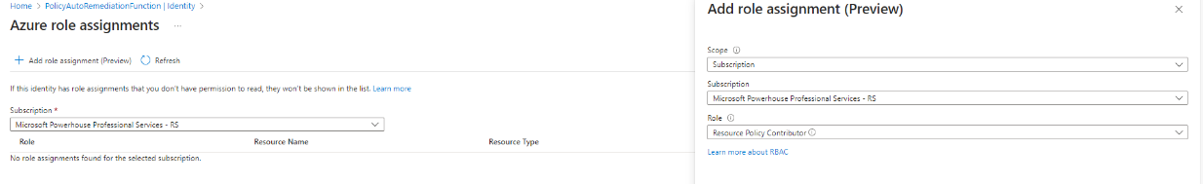

6.3 Function
The Function inside of the Function App will be running code to format the Event Hub data and write it to Log Analytics.
- Create the Function (inside of the Function App).
  - Go the Function App that you just created.
  - From the left-hand menu, in the Functions sub menu, click on Functions.
  - Click Create. A flyout menu will pop up on the right-hand side of the screen.
  - Leave the development environment as Develop in portal.
  - The next section will be Select a Template. In this search bar, type and search for "Azure Event Grid Trigger" and select it. You can accept the default name, but you can change the name to something that makes sense to the solution and/or naming convention, in this case we used "EventGridTrigger1".
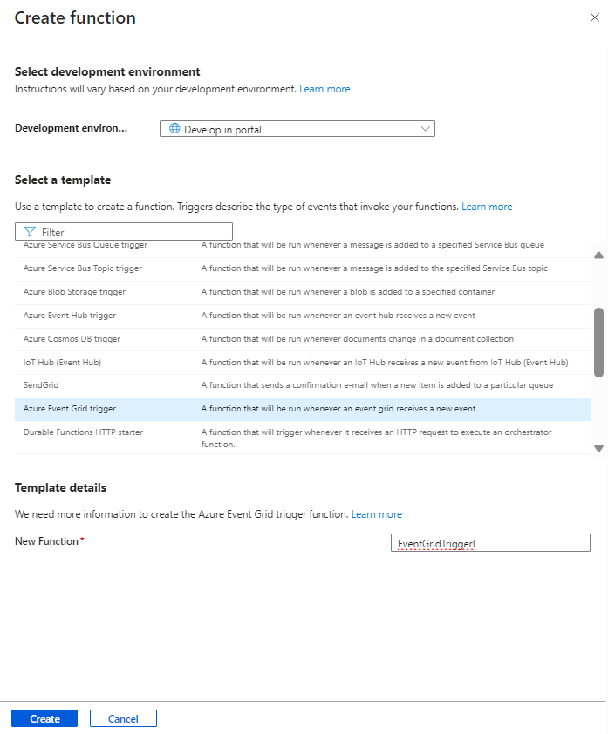
- Once the Function is created, select Integration to view the contents.
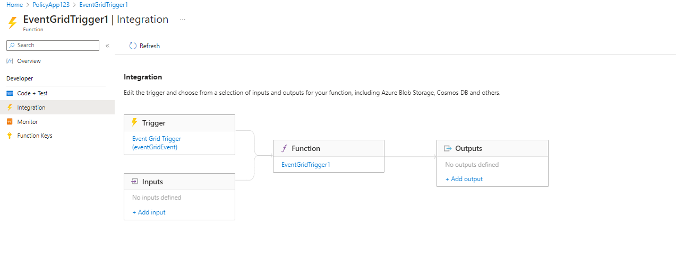
- Click to open the "Trigger" (eventGridEvent in this example).
  - Please note the "Event Trigger Parameter Name". This can be customized but it must match in the PowerShell code for the function. In this example, we will use the default value of "eventGridEvent".
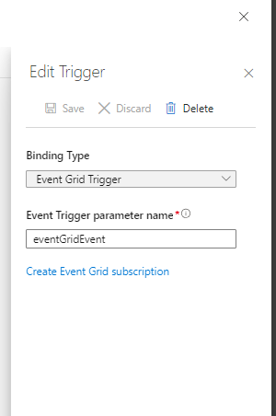
- Next, click "Create Event Grid Subscription".
- On the "Create Event Subscription" part of the portal, use the following options/values.
  - Name: EvtSub-PolicyAlert (this is customizable but should following naming conventions)
  - Event Schema: Event Grid Schema
  - Topic Types: Search for "policy" and select Microsoft PolicyInsights.
  - Source Resource: Azure Subscription *(might be autofilled)
  - System Topic Name: egst-PolicyAlert (or the name you created) *(might be autofilled)
  - Event Types: Policy Compliance State Created, Policy Compliance State Changed
  - Endpoint Type: Azure Function * (might be autofilled)
  - Endpoint: EventGridTrigger1 (Your Azure Function created in the previous step) * (might be autofilled)
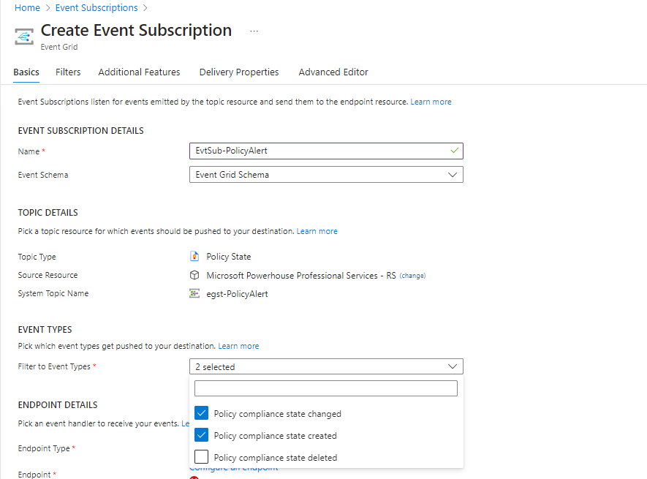

6.4 Data Collection Endpoint
The Data Collection Endpoint is part of the Log Ingestion for writing the PolicyInsights data to Log Analytics.
- In the Azure global search, type Monitor. Select Azure Monitor and open in the Portal.
- On the left menu bar, under the Settings submenu, click "Data Collection Endpoints".
- Click + Create to create a new Data Collection Endpoint (DCE)
  - Name the DCE, in this case, DCE-PolicyAlerts
  - Ensure that the correct subscription is selected.
  - Ensure that the correct resource group is selected.
  - Ensure that the correct region is selected.
  - Add any appropriate tags.
  - Click on Review and Create
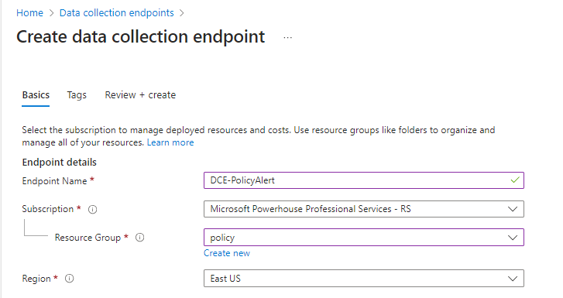

6.5 Log Analytics Workspace (LAW)
These steps will show how to create a Log Analytics Workspace
- Go to the Azure global search bar and type in Log Analytics Workspaces (LAW), Create new Log analytics Workspace: Name: lgwfordemo.
- Click on Review and create.
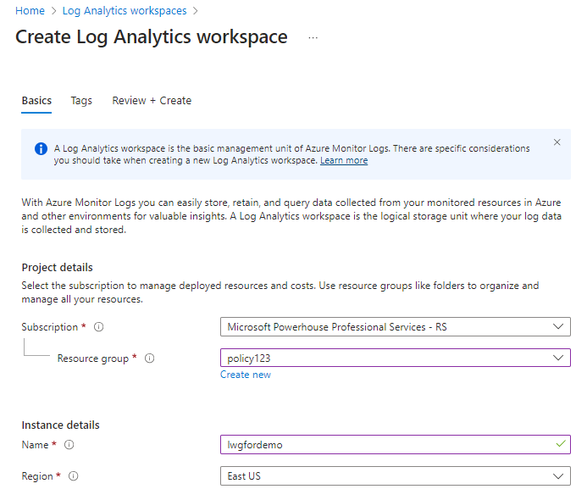

6.6 Custom Log (Table) in LAW and Data Collection Rule
These steps will show how to create a customer data table in the Log Analytics Workspace and create a Data Collection Rule.
- Go to the Azure global search bar and type in Log Analytics Workspaces (LAW)
- Open the lwgfordemo, from the lefthand side menu, under settings, select Tables.
- Select +Create, and then select New custom log (DCR-based)
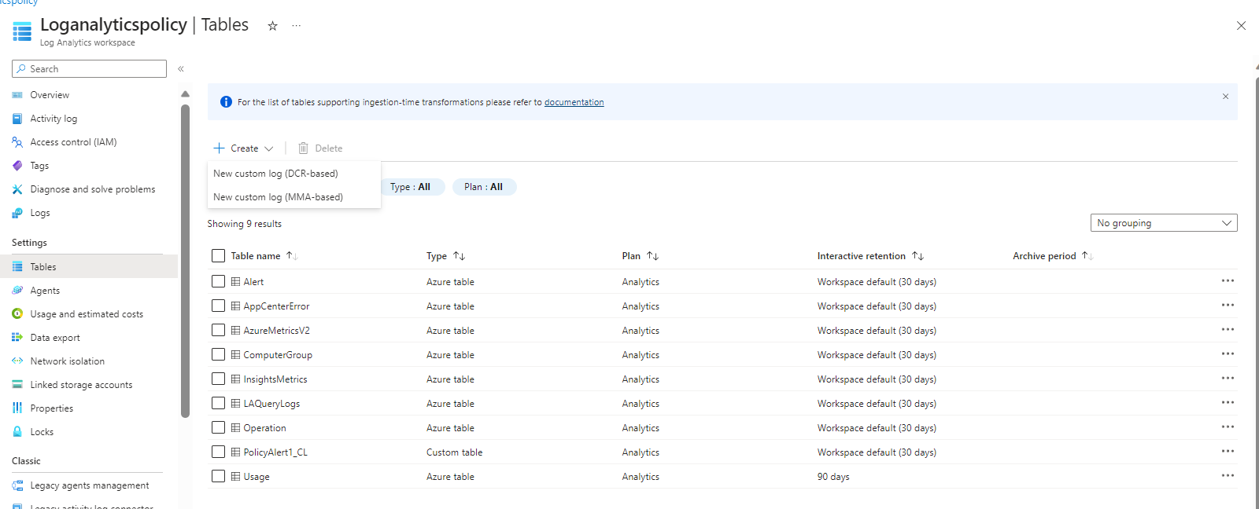
- On the Create page, name the Table in this case, the table is called PolicyAlert.
- Next, click "Create Data Collection Rule" blue hyperlink. (This Table which we just named, will be where you will be sending your policy data.)
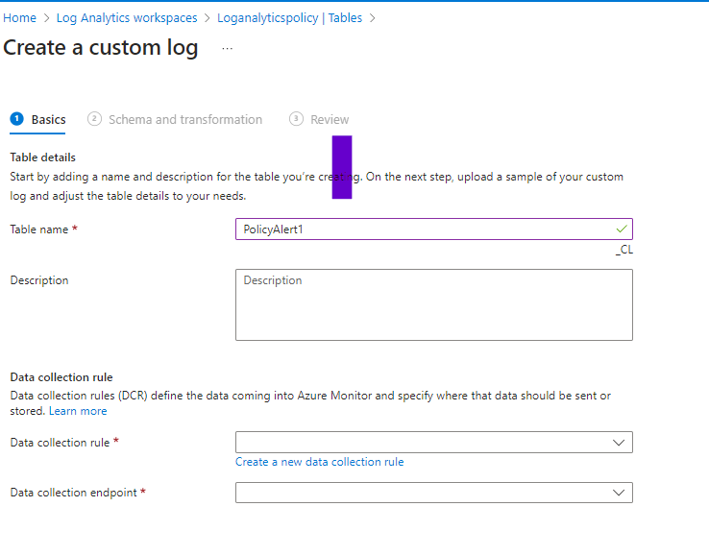

- Give the new DCR a name, in this case, it is named DCR-PolicyAlert. Click Done.
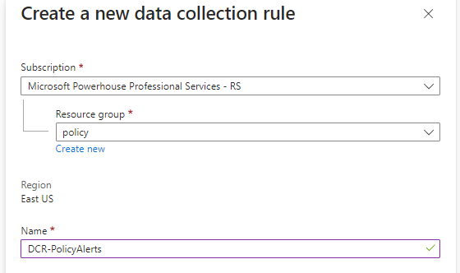
- When back at the "Create custom log" page, select the Data Collection Rule, DCR-PolicyAlert, you just created if it did not auto populate.
- Select the Data Collection Endpoint (DCE) that you created earlier in Azure Monitor. In this case the DCE is DCE-PolicyAlerts
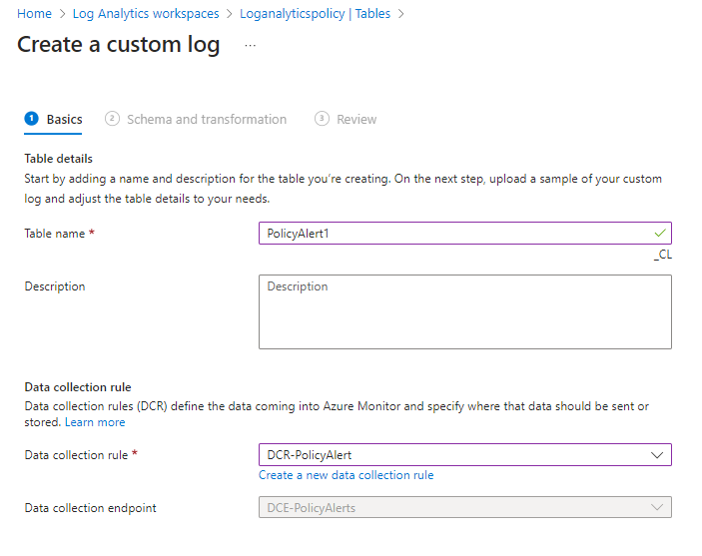

- Click Next to continue
- Setting up the data format/schema is the next step. In this step, you will upload in a schema of table.(refer Point no.13 for schema)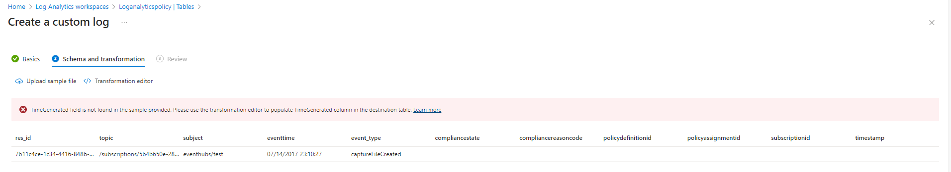
  - When you upload the sample file (or any other), you will likely get an error about the "TimeGenerated" data field. This is an expected error. This field is required in Custom Tables so you will next need to "transform" a data/time field in our sample data to suit the Custom Table. If you get this error, click the "Transformation Editor" in the previous image. The following image shows the query you can use. Type in the following KQL. Run the query and then click Apply.
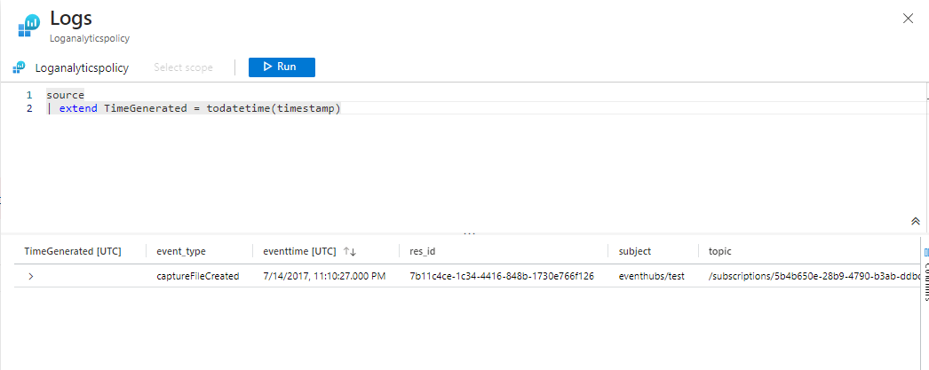
  - You should now be able to click Next to continue.
  - Click the Create. *Please note you will see the table name appended with _CL. In this case, PolicyAlert_CL is the name of the custom table.
- Create one more table for Policy remediation, Named it as: PolicyRemediationAlert.
- Schema for tables: PolicyAlert, PolicyRemediationAlert

6.7 Setup Access to the Data Collection Rule
This process will setup access to the Data Collection Rule as part of writing the data to Log Analytics via the Log Ingestion API.
- Go to Azure global search. Type Monitor and select it.
- Within Azure Monitor, go to Settings, and click "Data Collection Rules" on the left menu.
- Find the DCR created in the previous step and click on it.
- Once on the DCR you created, click "Access Control (IAM)" from the left hand menu.
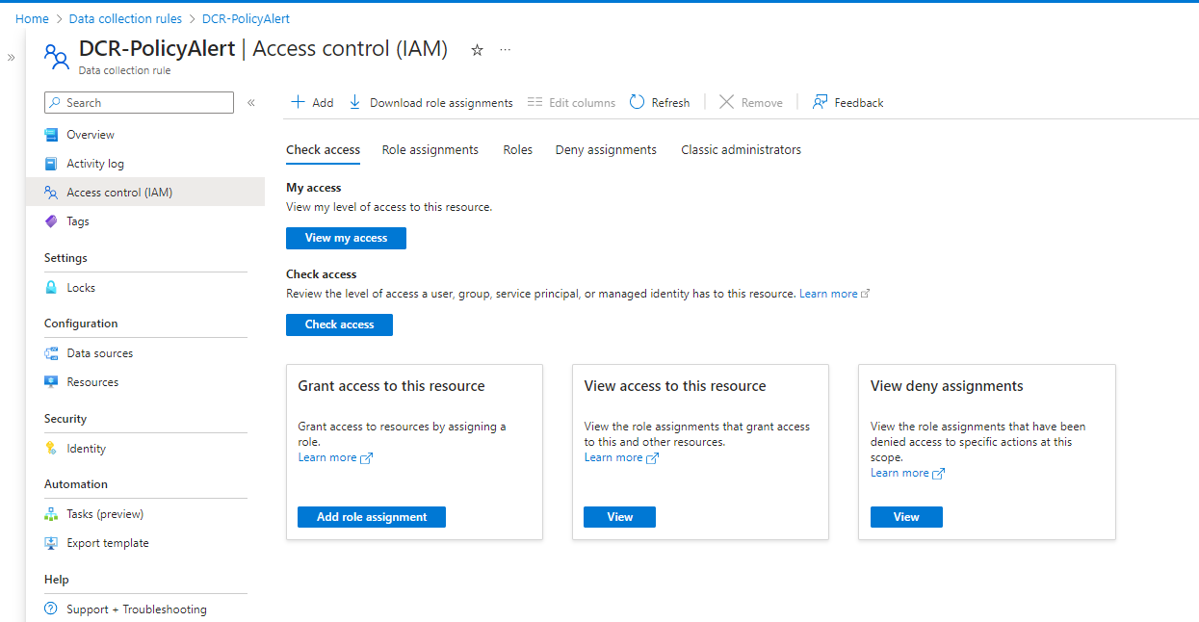

- Find Grant access to this resource, click "Add Role Assignment".
- Add the role "Monitoring Metric Publisher" to System Assigned managed identity of Function app
  - For Role, search for Monitoring Metrics Publisher. Select it. Click Next.
  - For Assign access to, select Managed Identity
  - For Members, select name of System Assigned Managed Identity of Function app.
  - Click Next
  - Click Review and Assign.
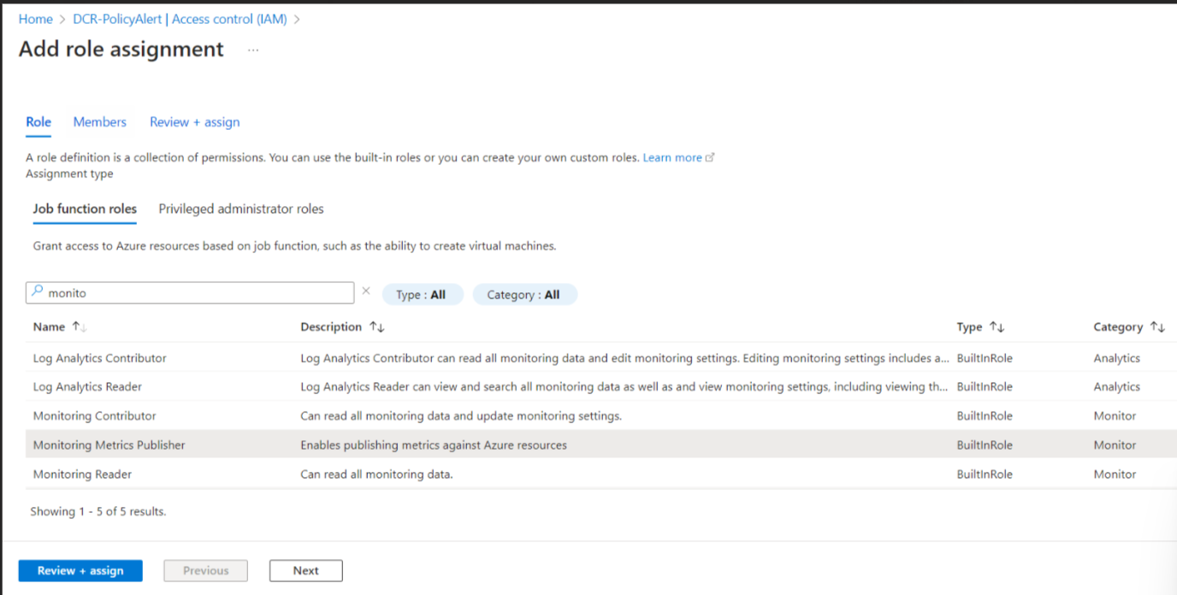
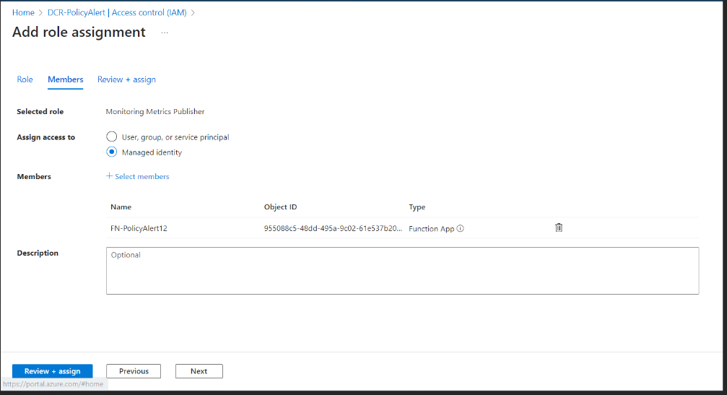

6.8 Setup PowerShell Operating Environment in Function App
This process will prepare your Azure Function PowerShell environment .
Go to your Function App that you created in a previous step.
- Under Functions, click on "App Files" on the left side.
There will be a drop-down menu near the top middle of your screen. Choose the "requirements.psd1" option.
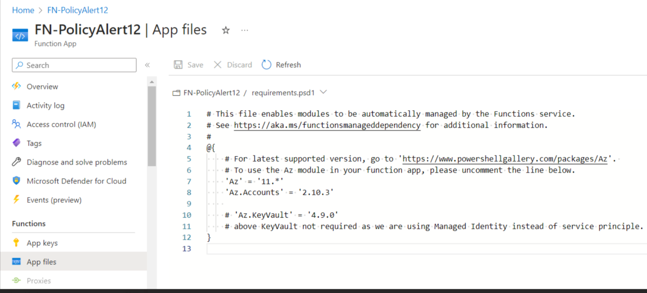

Edit the text in the file so that you have an entry for "Az.Accounts" indicated in the graphic, and then click "Save". This will tell your function to automatically install the PowerShell modules specified when the app restarts next.

With the Az module line uncommented, you now need to restart the function app.
- To do this, click on "Configuration" on the left bar, under Settings.

Navigate to the "General Settings" tab on the top right.

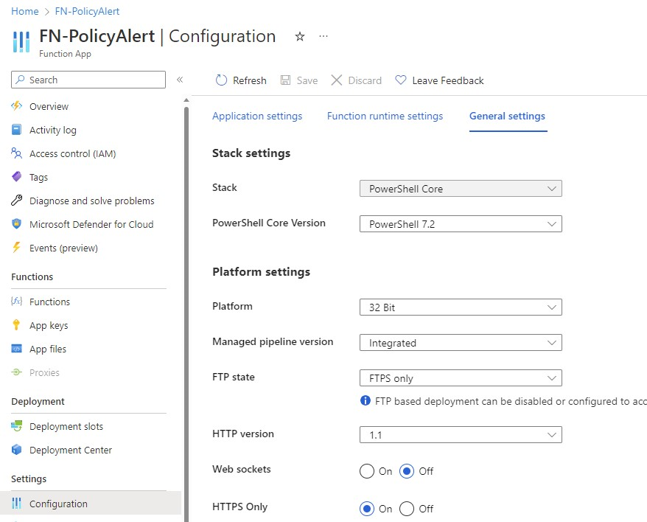

Find the setting "PowerShell Core Version" on the right and change it to a different value and click save. Acknowledge the change and wait until it completes. Once the task is completed, reverse that setting back to its original value and click save again. In my example, I went from "PowerShell 7.2" to "PowerShell 7.0" back to "PowerShell 7.2". This process is just to force Azure to restart the Function App so the Az Modules will load.
- **NOTE: This interface in the Portal may have changed so if you do not see the PowerShell Core Version on the Configuration page, you can use the Restart button on the top navigation bar on the Azure Function instead. **

Loading the PowerShell modules could take a few minutes so do not immediately expect it be there right after the restart completes.

When the PowerShell is executed in your function app, it should have the PowerShell Az modules loaded by default.

6.9 Setup PowerShell in Function
Here you will setup the PowerShell code within the Azure Function.
- In this section we will setup the PowerShell code and operating environment with the Function created in the previous step. For our reference architecture in this article, you can download the PowerShell source code from HERE.
- Go to the Function App, Policyapp123or what you called the Function App for this solution.
- Please define all secrets and plain text value in App setting.
3.1. Under Configuration>Application Setting>New Application Setting

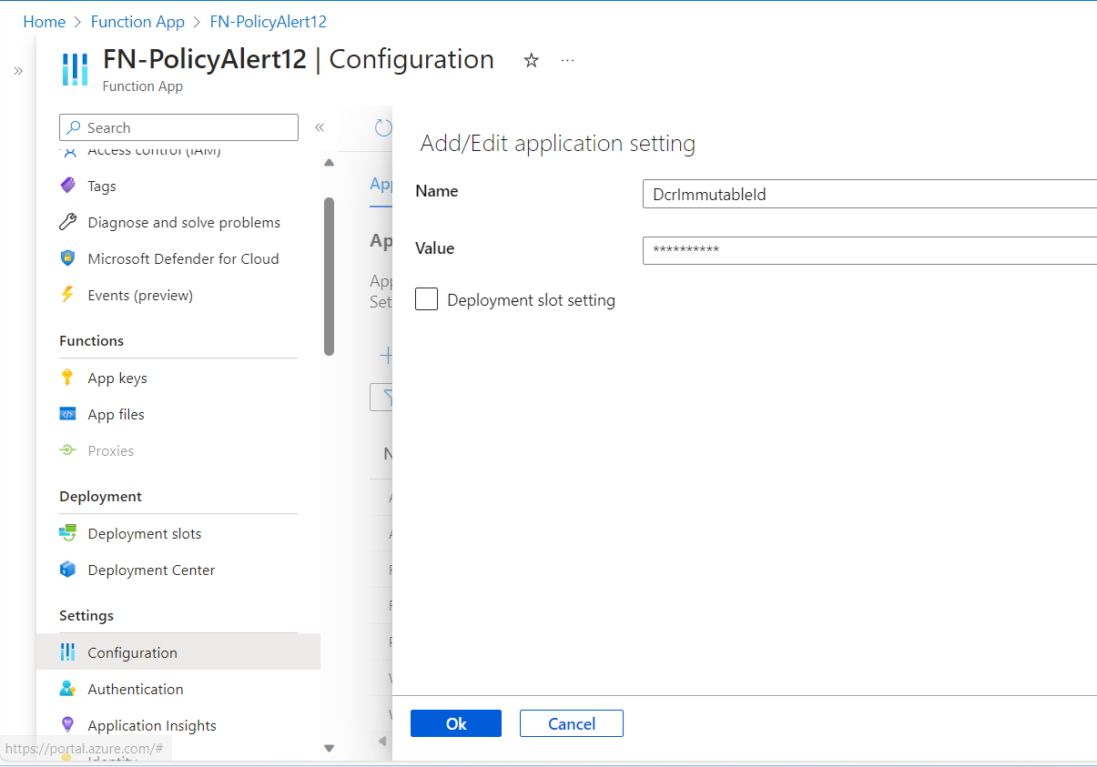
Name | Description
dataCollectionEndpointURI | Data Collection Endpoint URI(refer below image)
dataCollectionRulePolicyAlertImmutableId | Immutable ID for DCR created for Policy Alert (refer below image)
dataCollectionRulePolicyRemediationAlertImmutableId | Immutable ID for DCR created for Policy Remediation Alert (refer below image)
monitorCustomLogTablePolicyAlerts | Name of Custom table created in LAW for Policy Alert
monitorCustomLogTablePolicyRemediationAlerts | Name of Custom table created in LAW for Policy remediation Alert
ResourceGroupList | List of Whitelisted Resource Groups with comma separated
tenantId | Tenant Id
subscriptionId | Subscription Id
Image Reference to get DCE URI
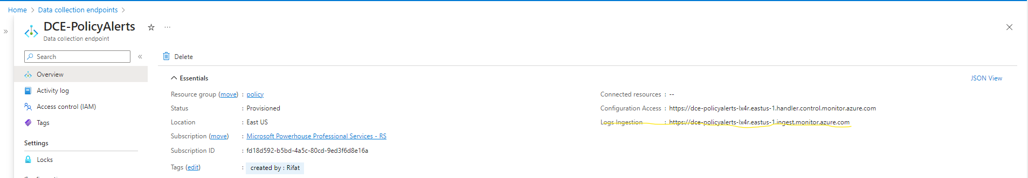

Image Reference to get Immutable Id
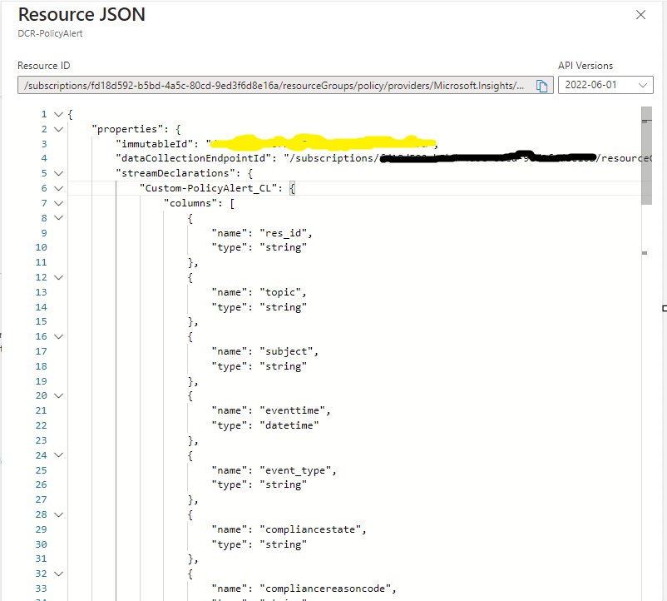
- From the left-hand menu, under Functions, select Functions.
- You should be able to see on the right-hand side, the function that was created earlier in this solution called, "EventGridTrigger1", and click on it to open it.
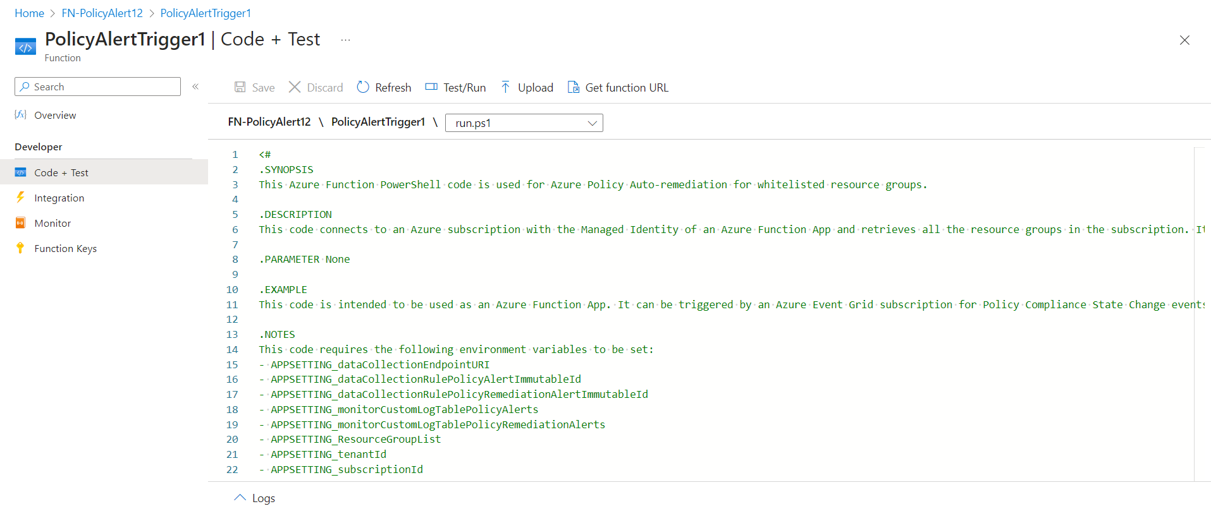

- On the left menu, under Developer, click "Code + Test".
- This will open the code editor. Paste the PowerShell script. Copy code from HERE.

6.10 Setup Alerting
Here you will setup the alerting mechanism within Azure Monitor.
- Go to the Log Analytics Workspace (LAW) where you have sent the Custom Logs.
- In a blank query space, please type or paste in the KQL query to query the custom log table for the policy compliance event changes (PolicyAlert). You will get data as like below,
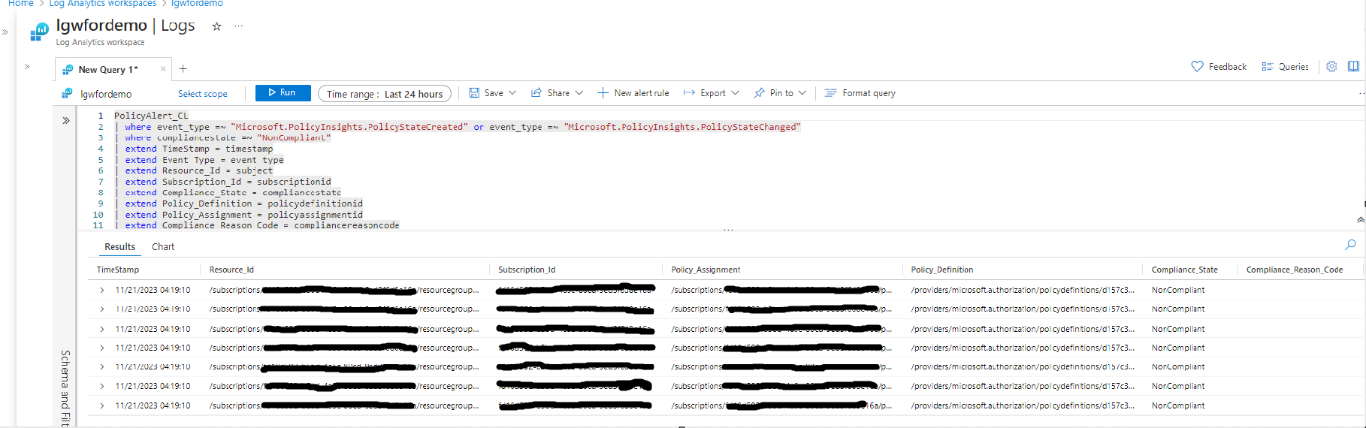
- In a blank query space, please type or paste in the KQL query to query the custom log table for the policy remediation event changes(PolicyRemediationAlert). You will get data as like below,
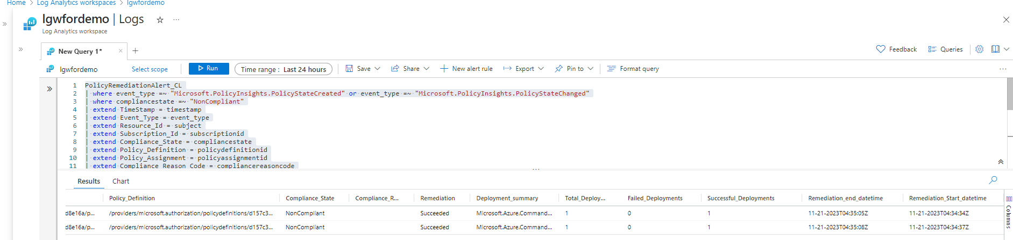

- Create new alert rule as per requirement, Click on “New alert rule.”
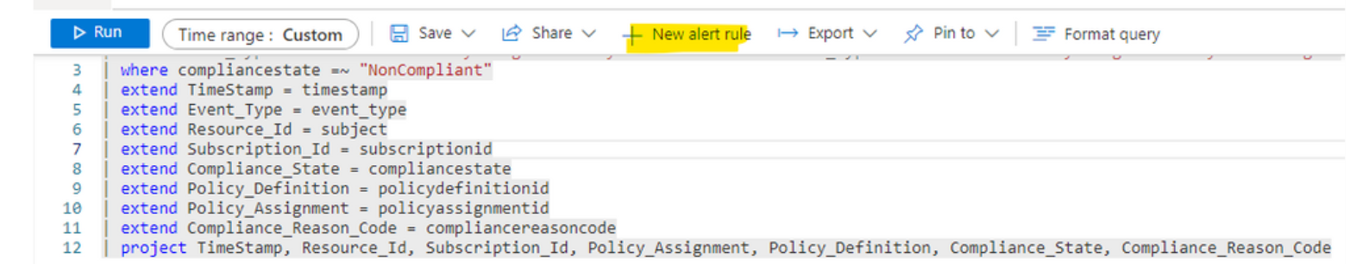
- On “Configuration”, configure the alert logic, In this case, select the operator as greater than and the threshold value as 0. We would like to be alerted when there is a policy compliance change. With these settings, we will be notified when the threshold value is greater than 0; so every time a change occurs.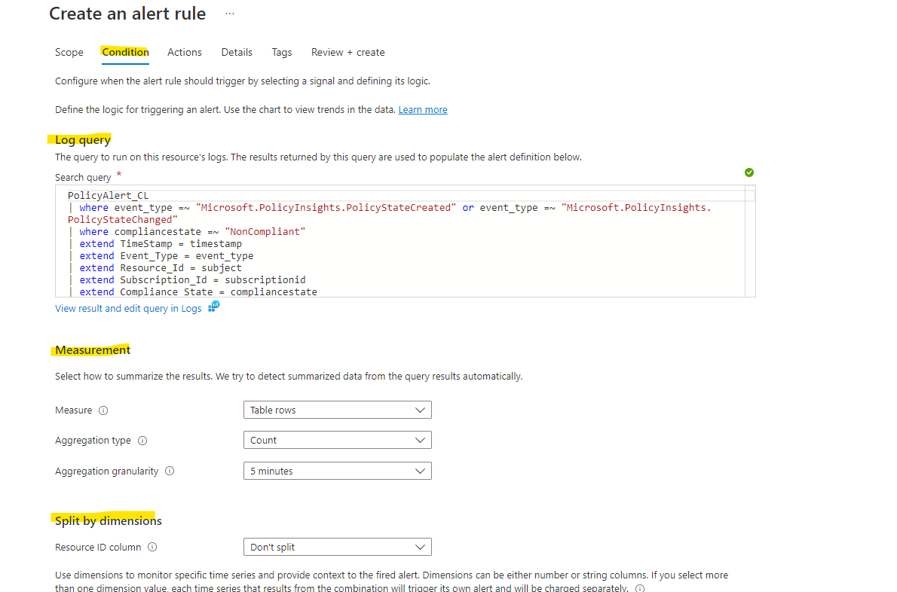
- Create an Action Group and configure email and mobile number where alerts to be send.

7.0 Result

1.Efficient Governance:
The solution effectively manages the complexity of dynamic cloud environments, ensuring real-time tracking and adaptability to changes in resources.
2.Proactive Compliance:
Resources consistently adhere to company policies, with prompt identification and resolution of non-compliance issues.
3.Automated Agility:
Streamlined alerting, automation for remediation, and resource whitelisting strike a balance between compliance and business agility.
4.Exception Handling:
Resource whitelisting allows for exception handling during policy remediation, providing flexibility in policy application.

8.0 References

https://techcommunity.microsoft.com/t5/fasttrack-for-azure/generate-azure-policy-compliance-alerts-by-sending-custom-data/ba-p/3671119
https://michaeldurkan.com/2023/03/14/the-a-z-of-azure-policy/
https://adatum.no/azure/azure-policy/remediate-azure-policy-with-powershell
https://4sysops.com/archives/manage-azure-policies-using-powershell/
https://charbelnemnom.com/get-the-list-of-non-compliant-azure-resources-with-powershell/
https://learn.microsoft.com/en-us/azure/key-vault/general/quick-create-portal
https://learn.microsoft.com/en-us/azure/azure-monitor/logs/tutorial-logs-ingestion-portal
https://learn.microsoft.com/en-us/azure/azure-monitor/logs/tutorial-logs-ingestion-portal

